Sharon Kim

12/13/18

Vincent Berardi

CS 614—Interactive Data Analysis Final Project

**Measuring Media Representation Through Time Magazine Faces**

**Introduction**

The goal for my project was to determine how representation in media has changed over the past 100 years through analyzing the faces that were printed in *Time* Magazine issues. *Time* has the world’s largest circulation for a weekly news magazine and sets out to tell the news through people. The people and faces that are published in these issues presents itself to be a great medium to analyze. The *Time* Magazine face images were obtained by human workers via MTurk. MTurkers manually extracted and labeled each photo. Each photo was given labels for category, gender, race, age, whether the person was smiling or not smiling, and quality of photo. Gender representation in media has been a controversial topic in the past decade, so this project aims to measure representation starting from 1927 to 2012, and to see if there is actually a disparity.

**Data Preprocessing**

All of the images that were saved through MTurkers were available to download from a server, and were downloaded with Filezilla through the file transfer protocol (FTP). Using the FTP method, I was successfully able to batch download 4777 images in minutes. Below are a sample of some of the photos that were downloaded ranging from 1927 to 2012.

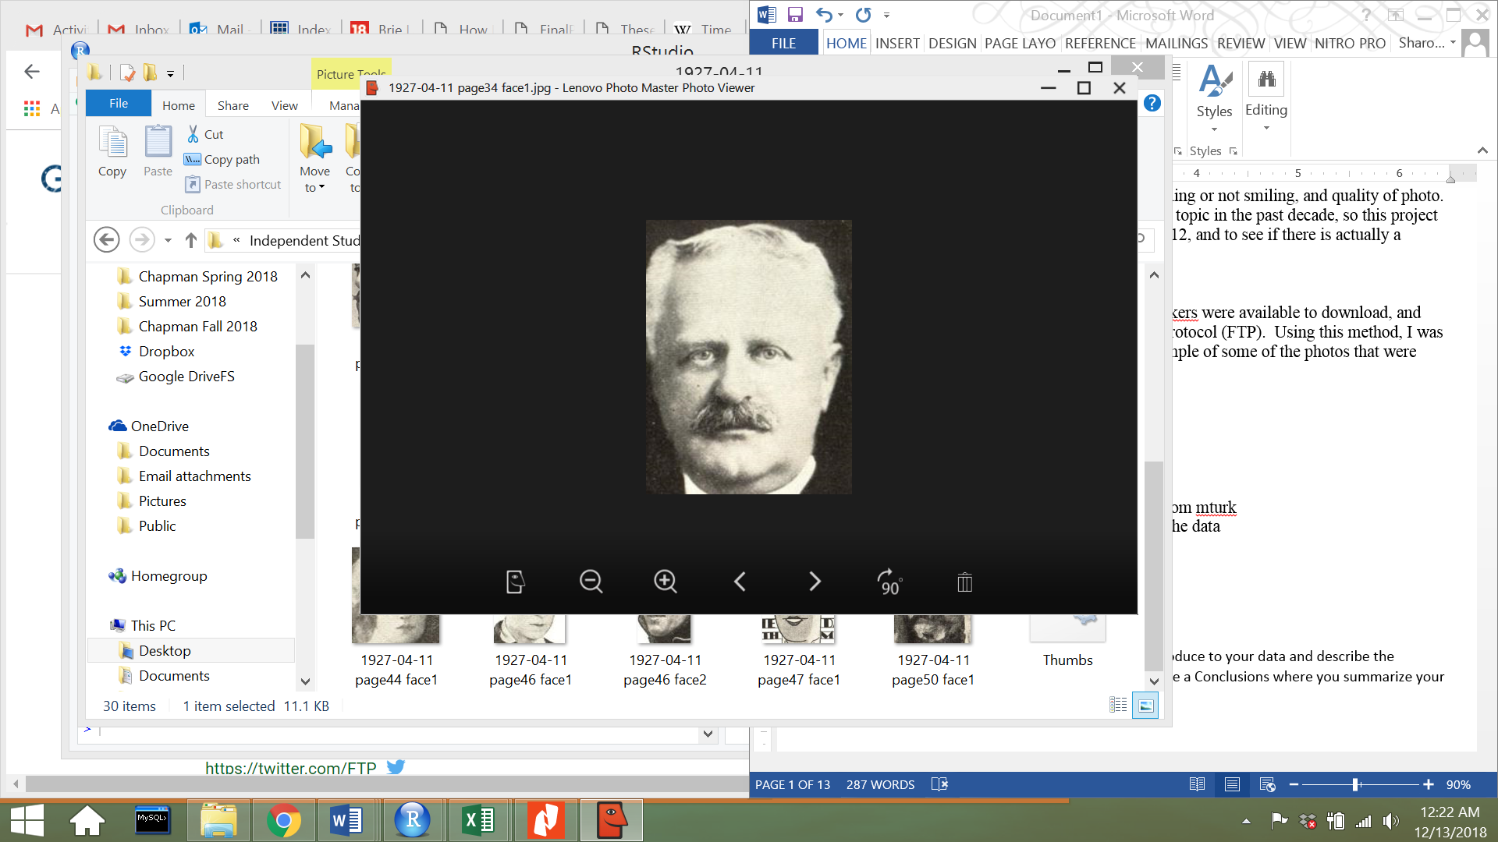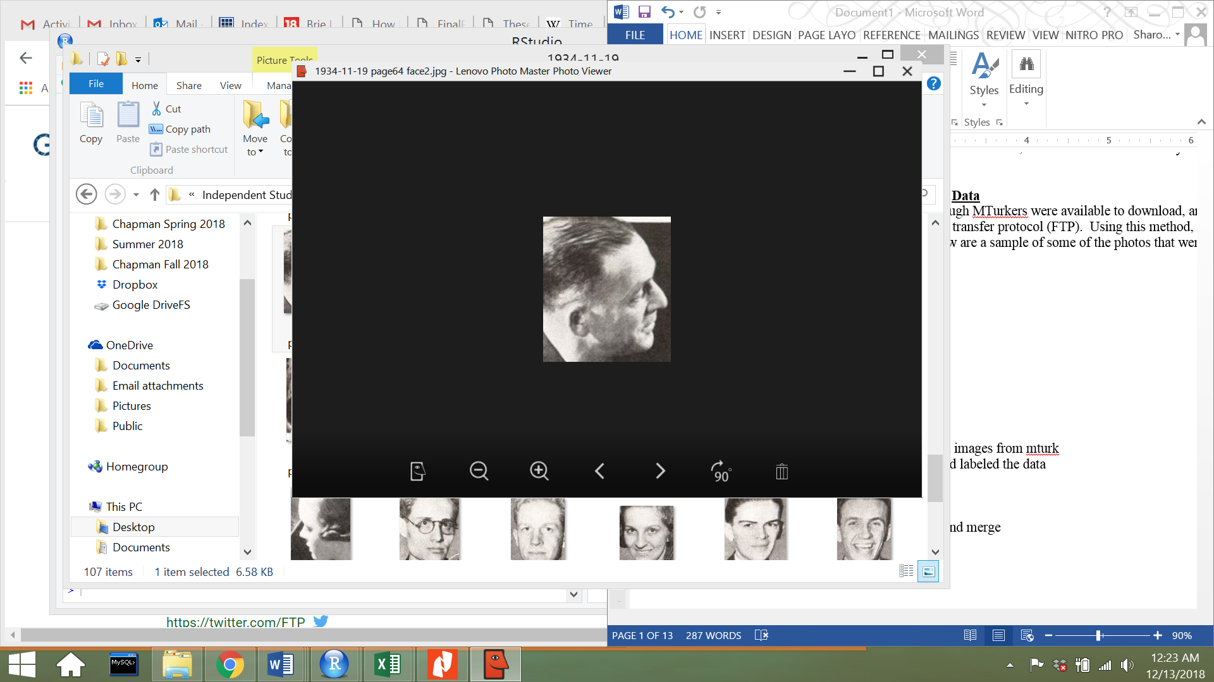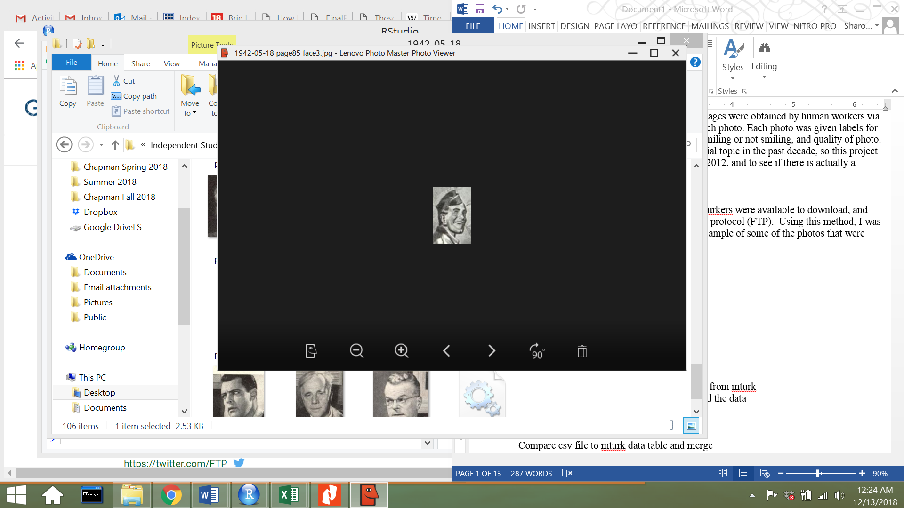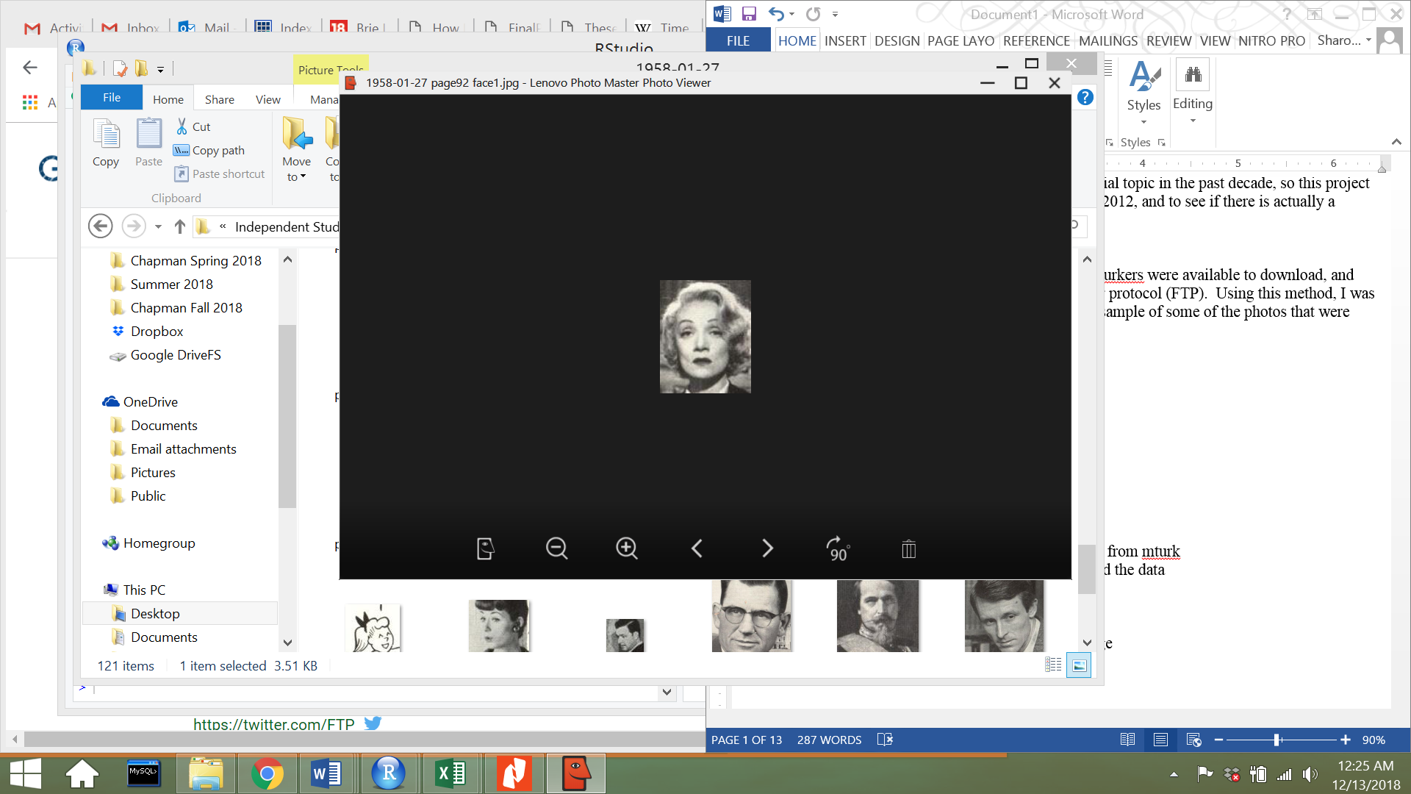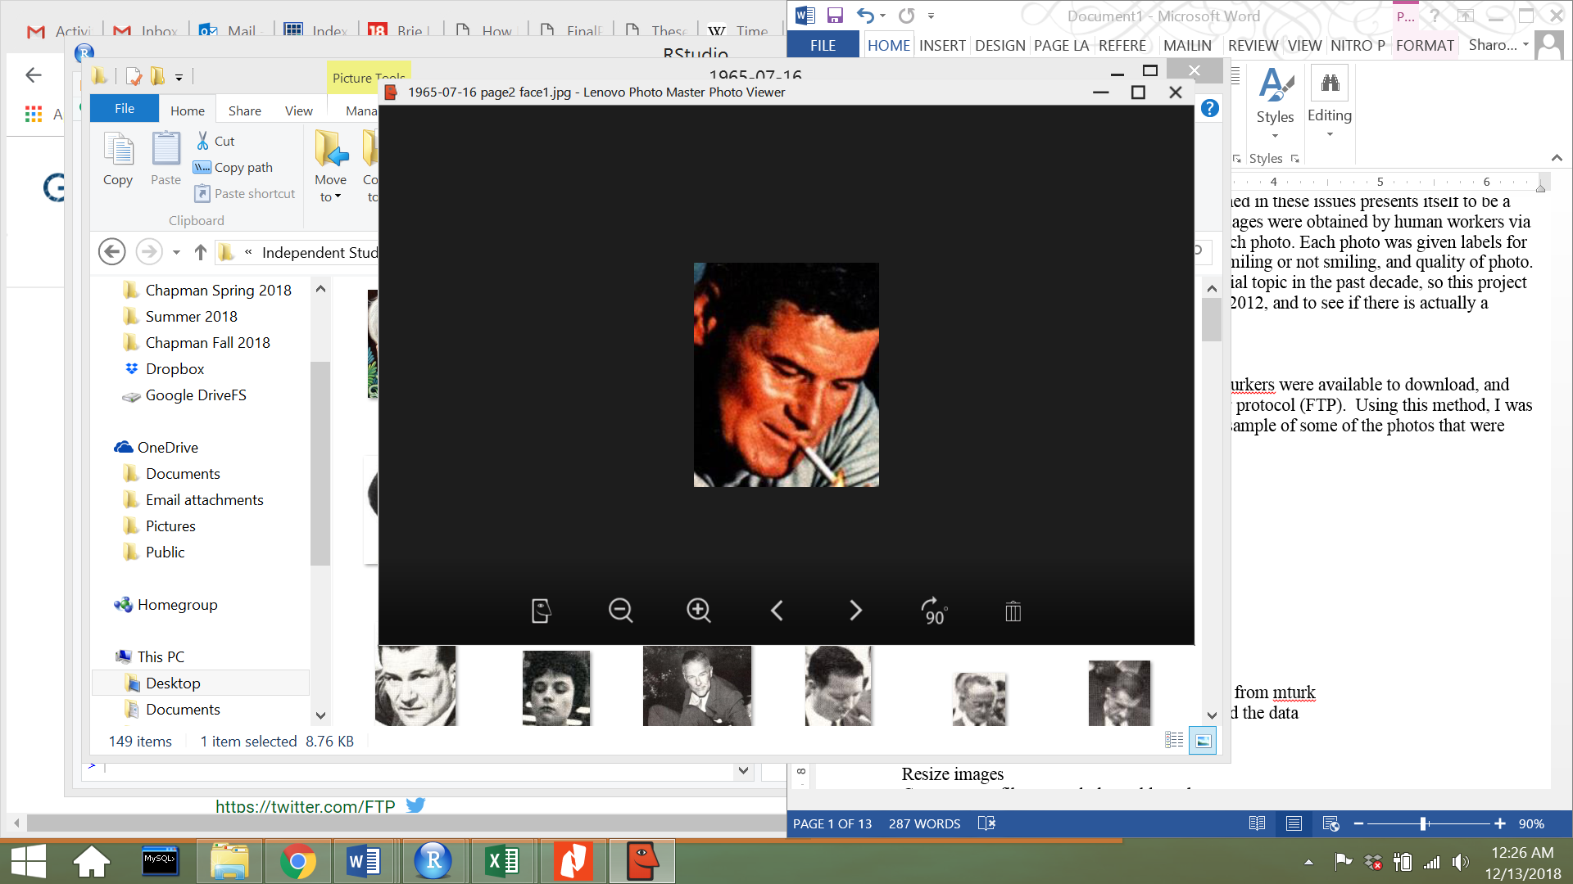

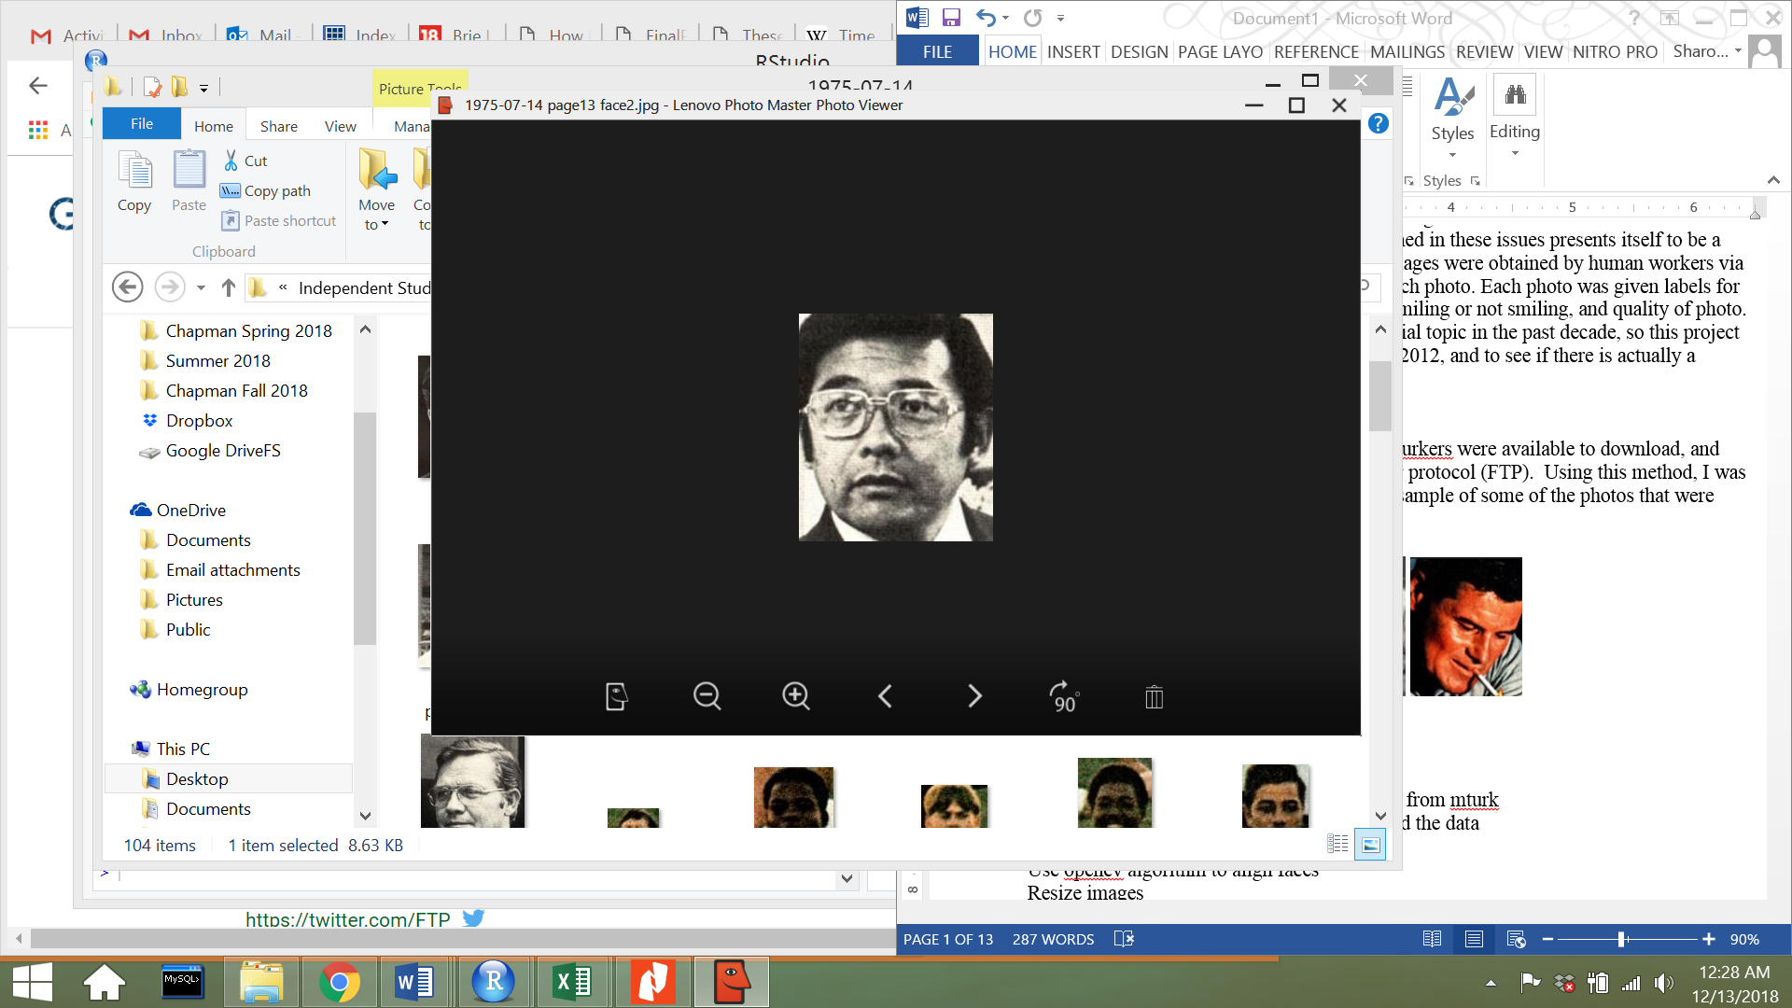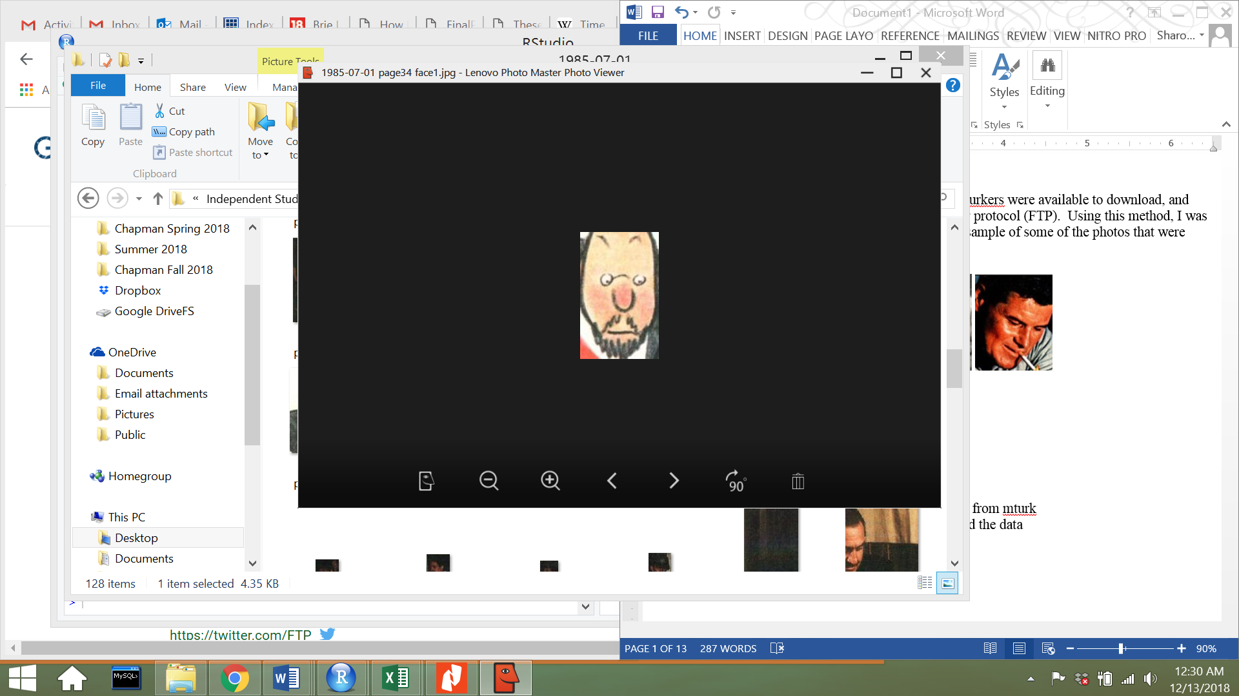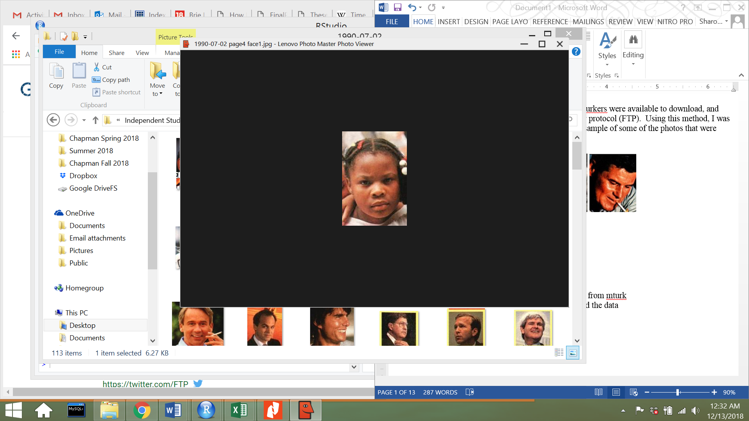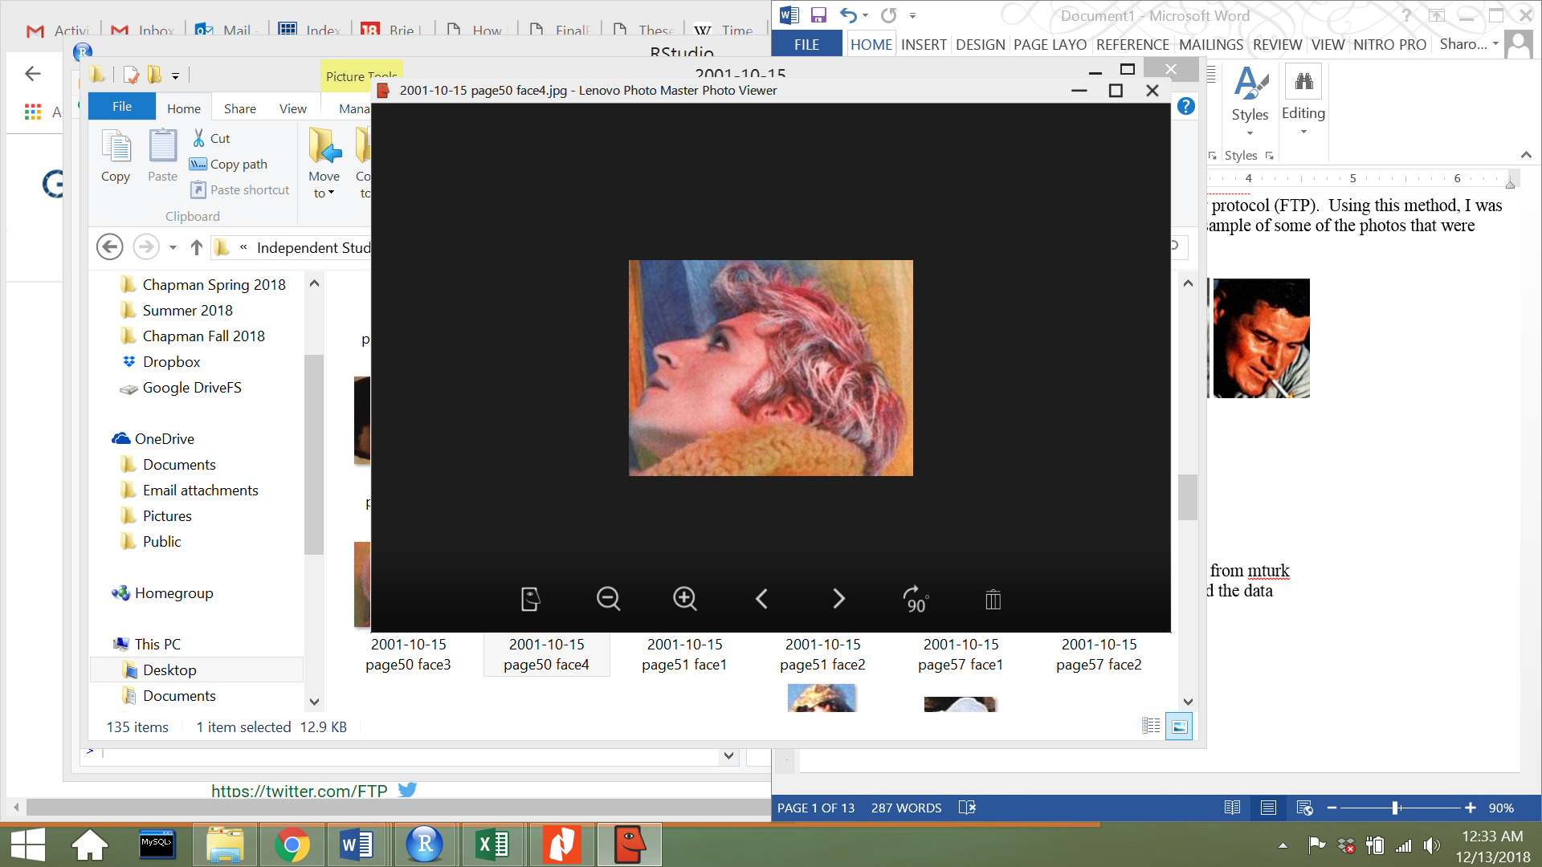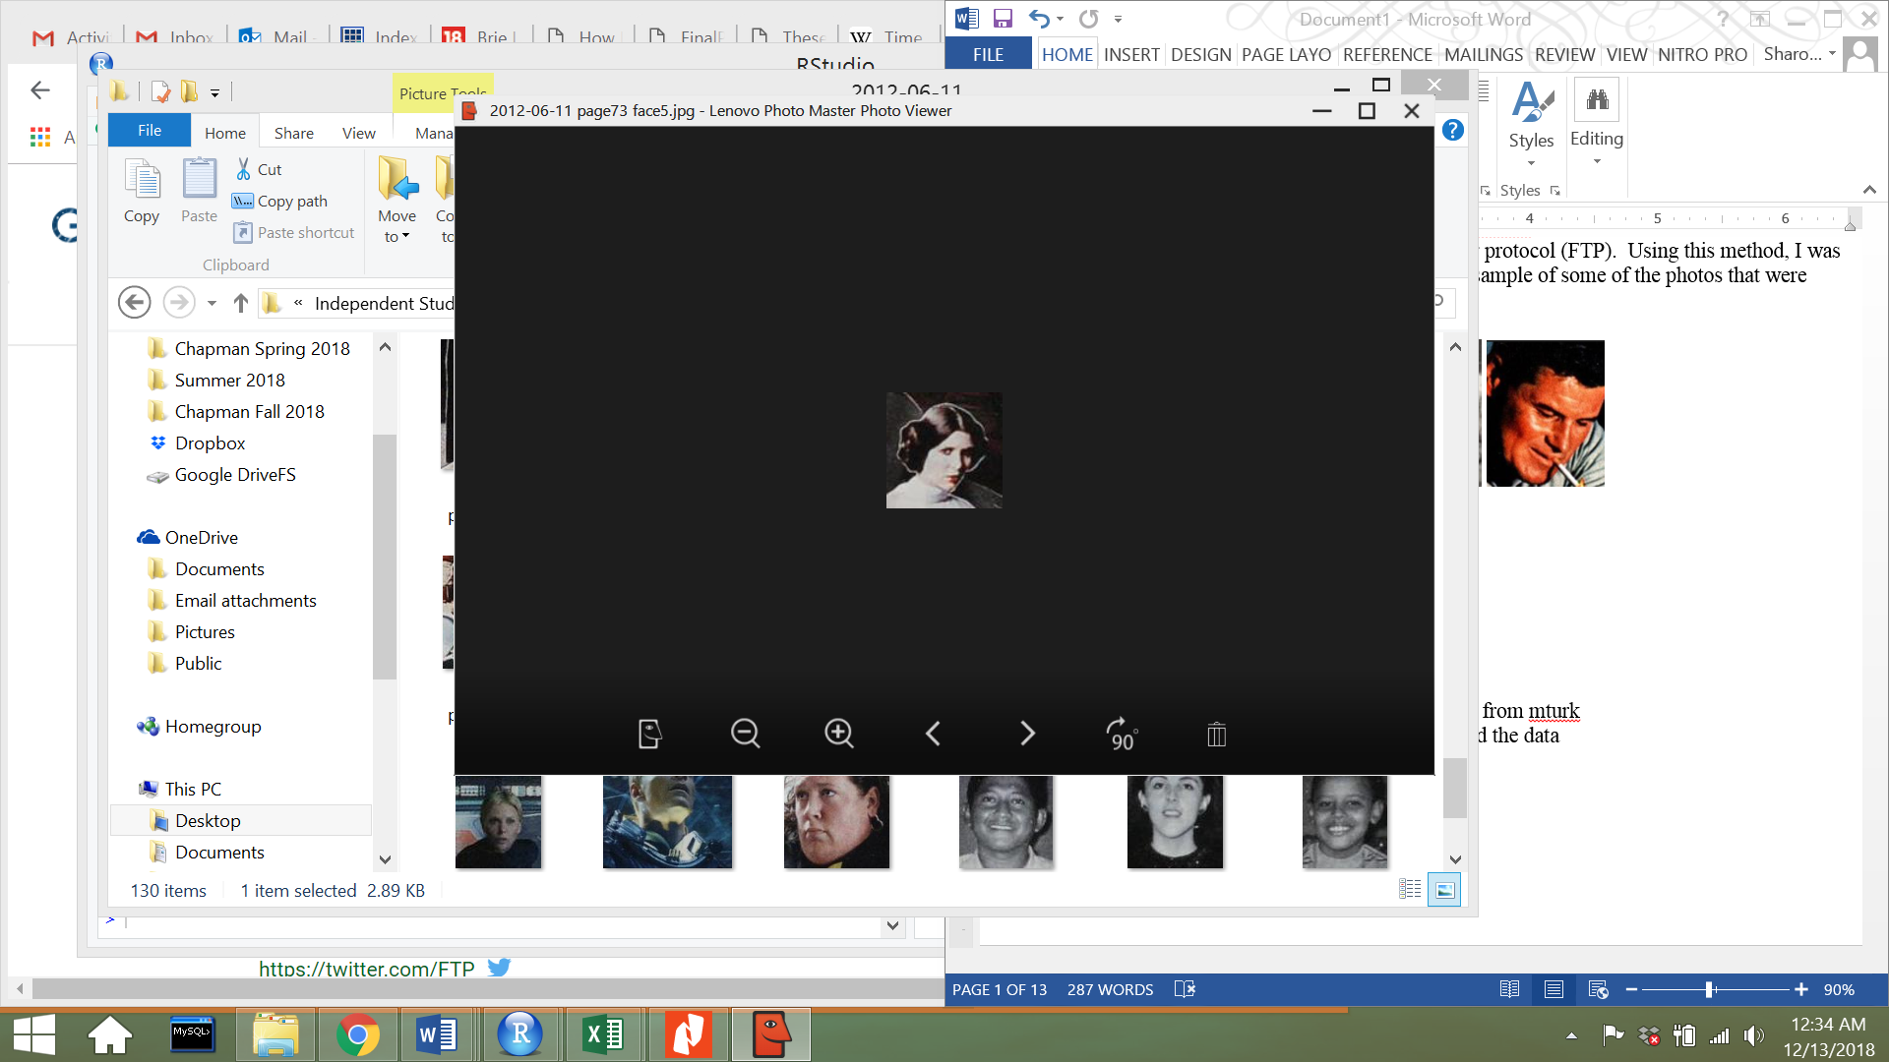

One way I wanted to summarize images were through calculating the mean-face for each decade. The mean-face algorithm was used because it was a very simple way to summarize hundreds of photos but also visually see changes in features over time. The mean-face algorithm first converts a single image to RGB pixel values. Next it takes a second image and converts it to RGB pixel values. The first image’s pixel value are added to the second image’s pixel values. This step is continued on until all of the images have been added together. Next, the sum of the pixel values are divided by the number of images that were added together. The result of this process is the mean-face of the images. R Studio was used to process the image data, and the imager library was extremely useful in loading the images and finding the average of all the faces.

The original faces underwent the mean-face algorithm, however, the original faces that were downloaded were varied in size and alignment. Many of the faces were side profiles, others were cartoon images, and others were slanted or tilted. Before filtering out the data, I attempted to find a mean-face of the images from the 1920s and produced a poor result. Data pre-processing was required to continue with the face analysis.



Through utilizing a facial detection algorithm through openCV, I was able to produce better results. Haar Feature-based Cascade Classifiers is a pre-trained face classifier in openCV that was trained through positive images (face images) and negative images (images without faces). Each feature is obtained by subtracting the sum of pixels in the positive images and the negative images. Some features that are obtained are edge features and line features. The facial detection algorithm in openCV provided a great way to filter through images were they had side profiles, and also align the images so that mean-faces could be calculated.

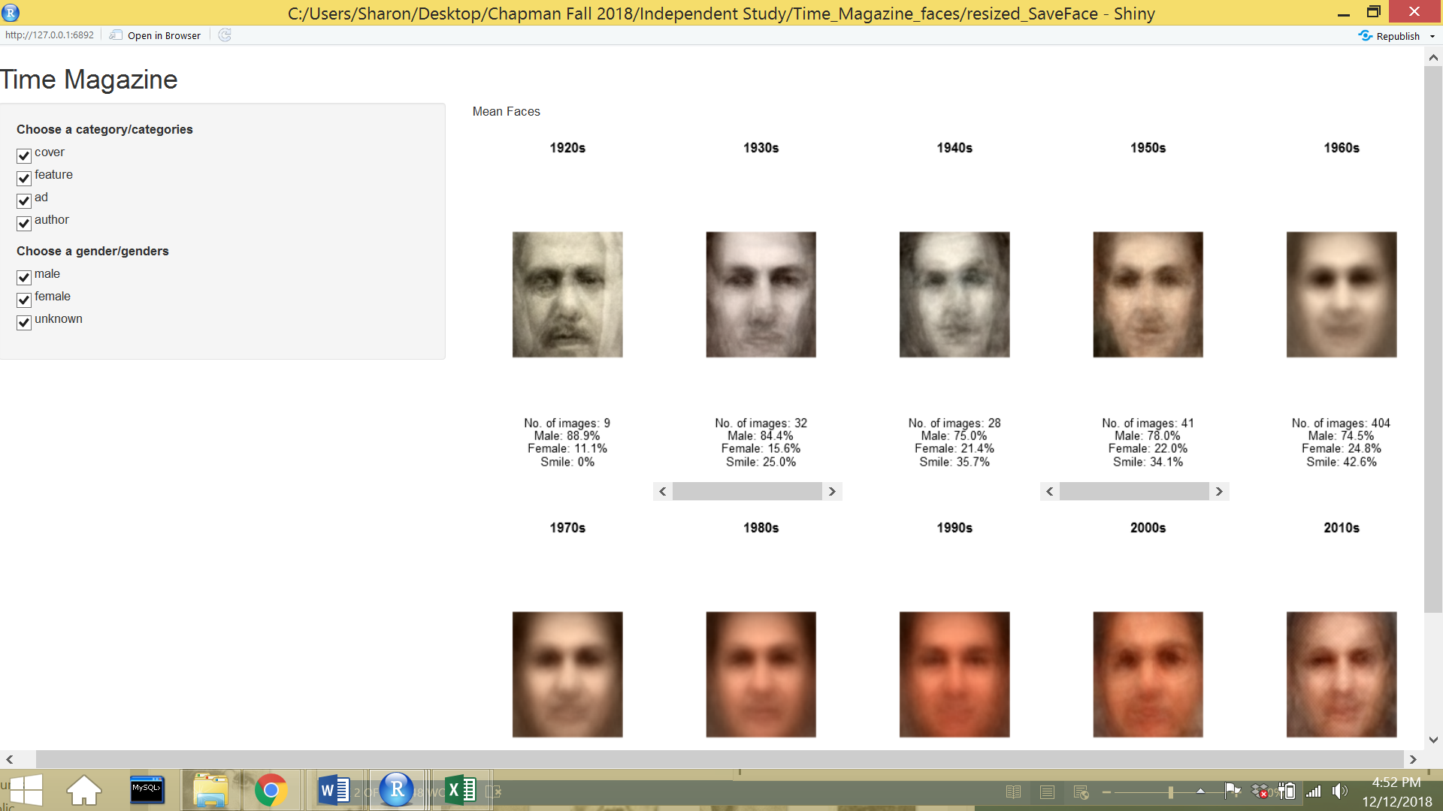

After applying the facial detection algorithm to the images, I was left with 1946 images. The image above above shows the result of a using a mean-face algorithm with the filtered data, which displays much better results. Next, I had to make sure that each image had the appropriate labels from MTurk that were in a different data table. After removing the images that did not contain the labels from MTurk, I was left with 1583 images to work with.

The mean and standard deviation of the distribution of images were calculated before pre-processing and after pre-processing to make sure the distribution did not change too drastically. A histogram was also plotted to visualize and determine if drastic changes in distribution occurred. The mean of the original images were calculated to be from around 1975, with a standard deviation of 15.273 years. The mean of the final images were calculated to be from around 1976, with a standard deviation of 14.841 years. Looking at the mean, standard deviation, and histogram distribution of the images, it looks like the distribution of data stayed the same, but the frequency of each image decreased over every year. After confirming that the representation of the data did not change drastically, we were able to proceed with data analysis on the 1583 images.

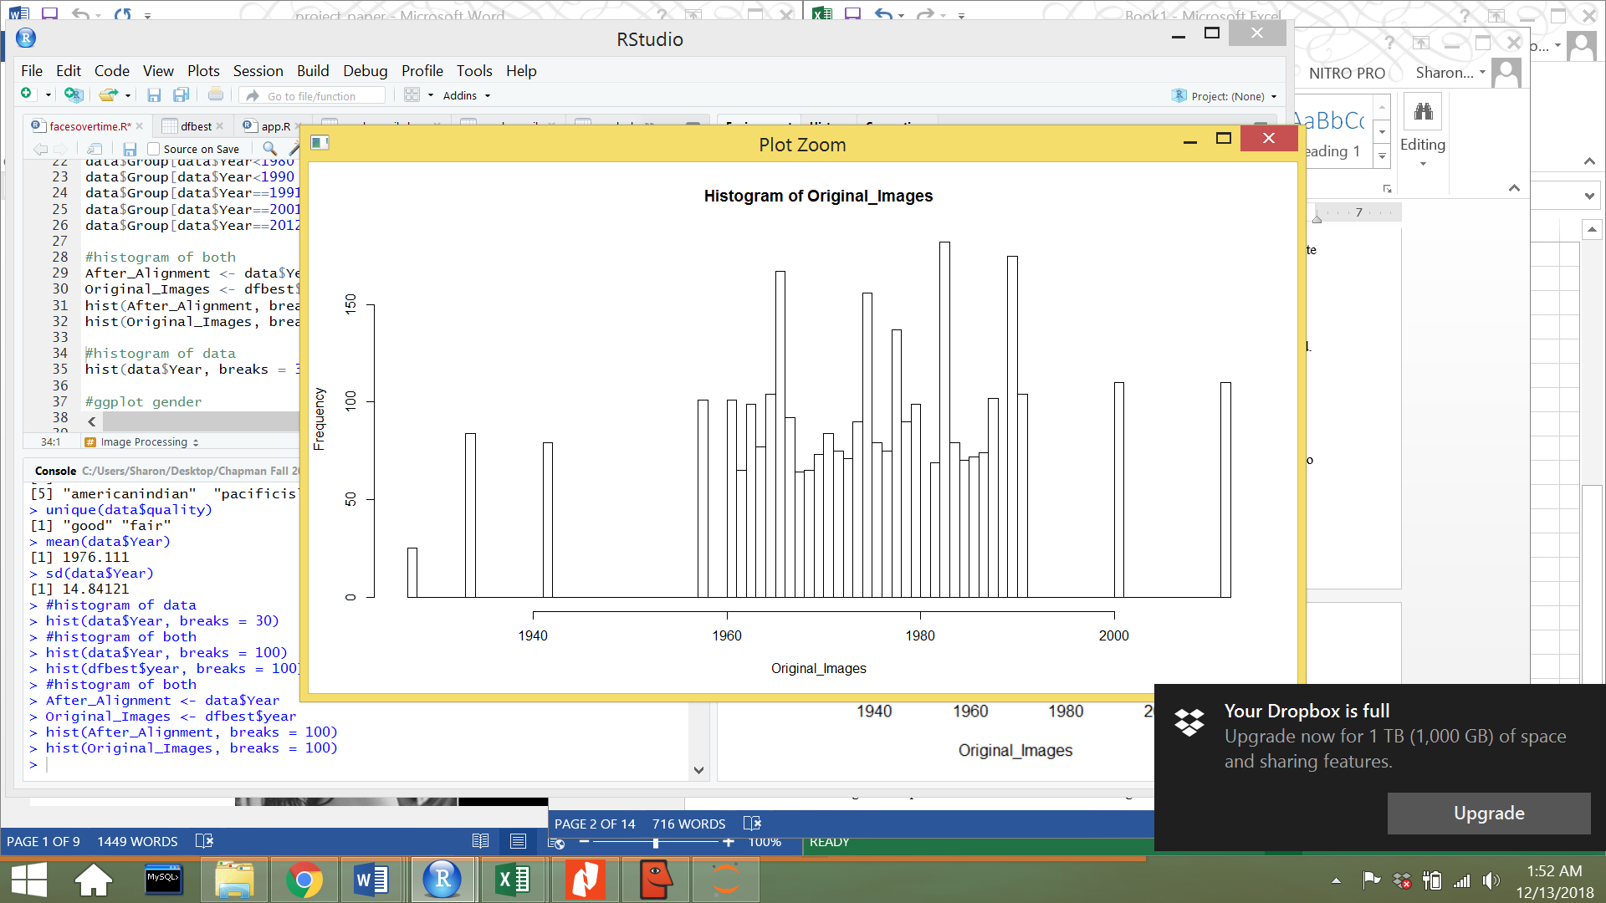

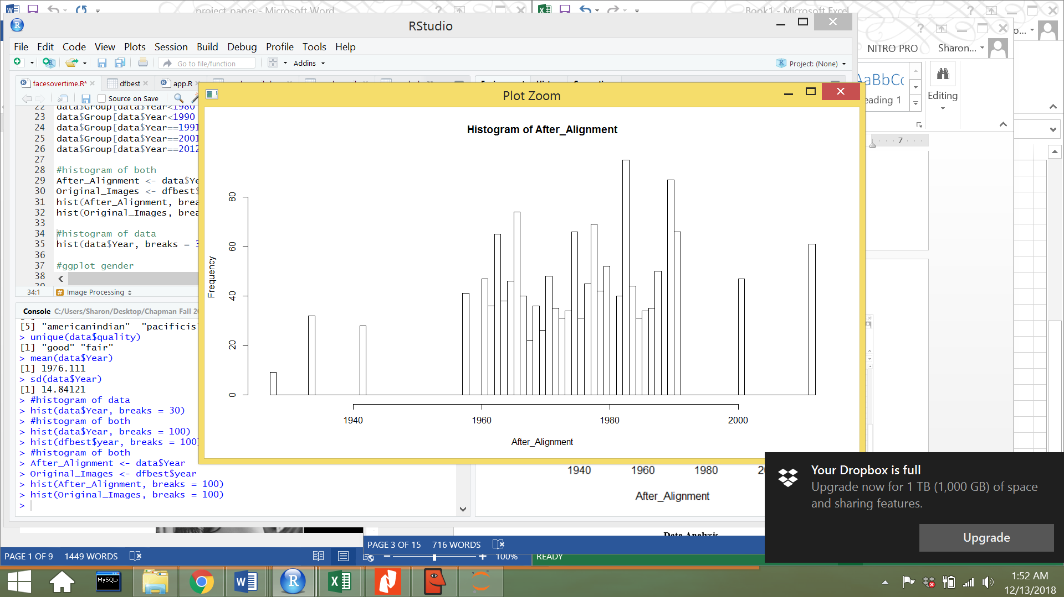

**Data Analysis**

The 1583 images that were left after pre-processing were the images that were used to do further analysis. Another data table contained further information about these images, and the information that the data table contained for each image were the date that the magazine was issued, whether the image was in color or black and white, the category the image fell under (cover, ad, feature, author), the gender of the photo (male, female, unknown), the race of the face (White, Asian, Black, unknown, American-Indian, Pacific Islander), whether the image was an adult or a child, if the person in the photo was smiling or not smiling, the quality of the photo (good, fair), and the dimensions of the photo. Below are some photos after the pre-processing step.

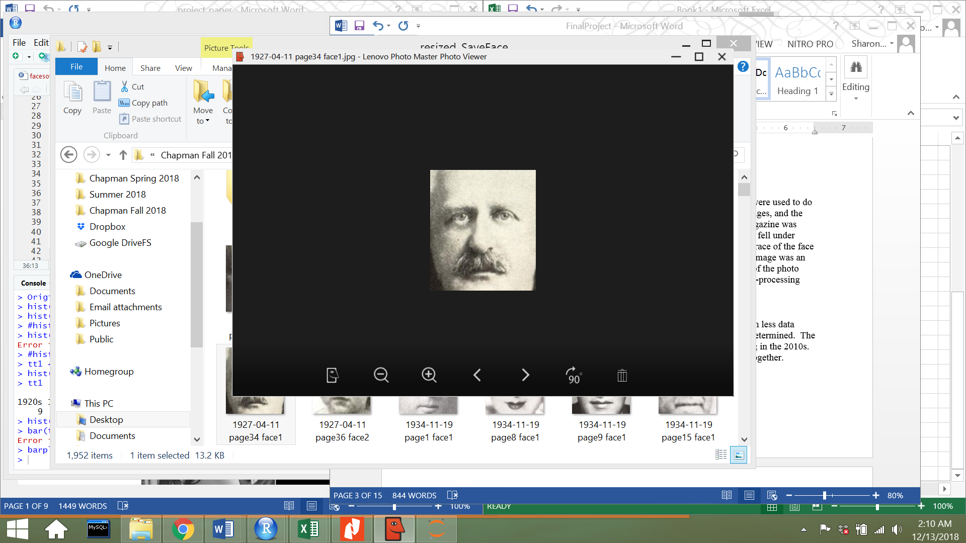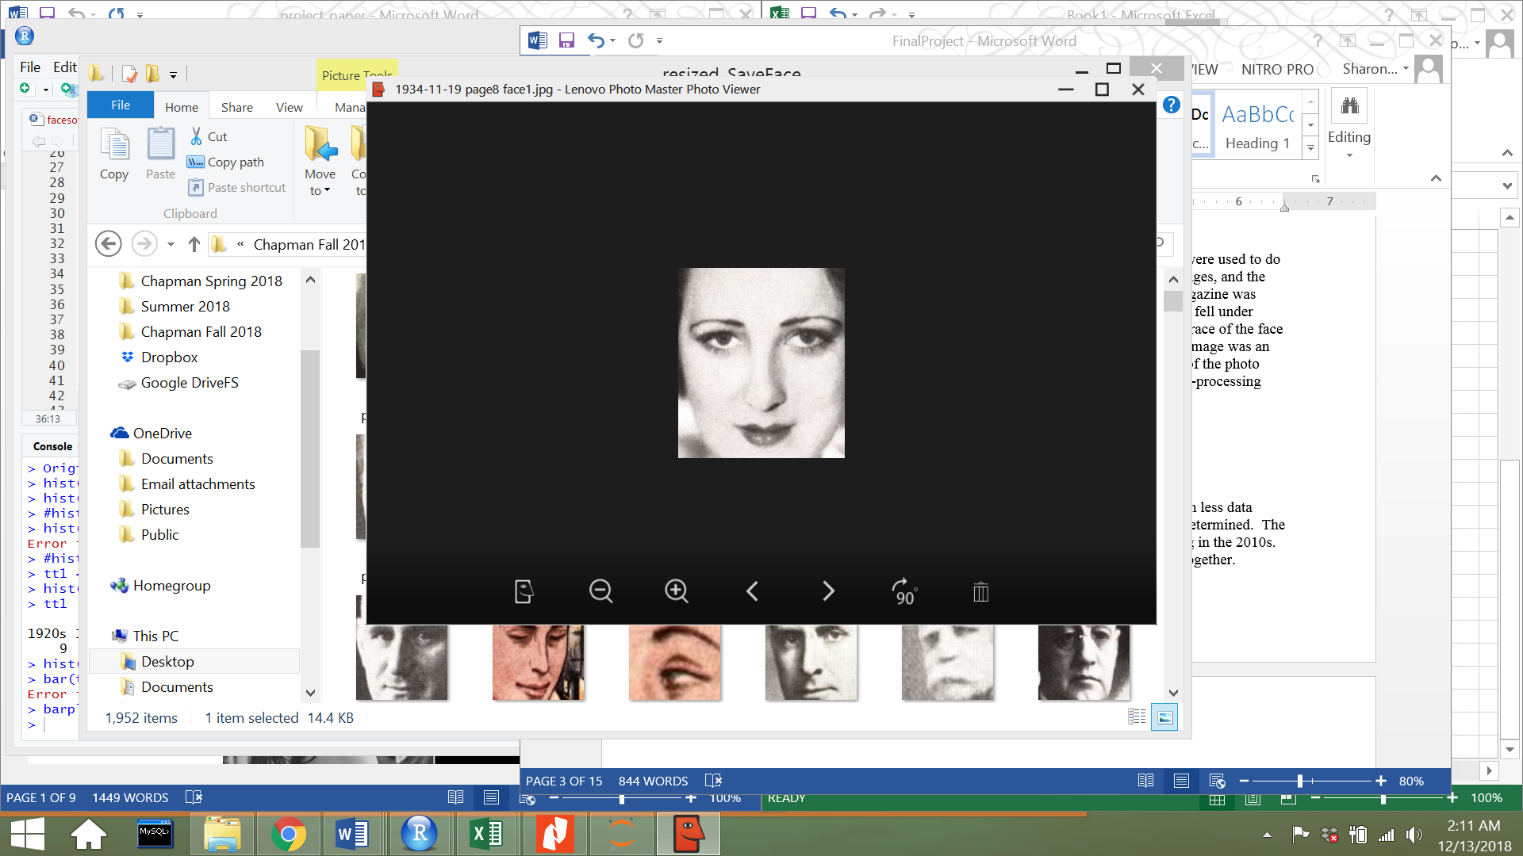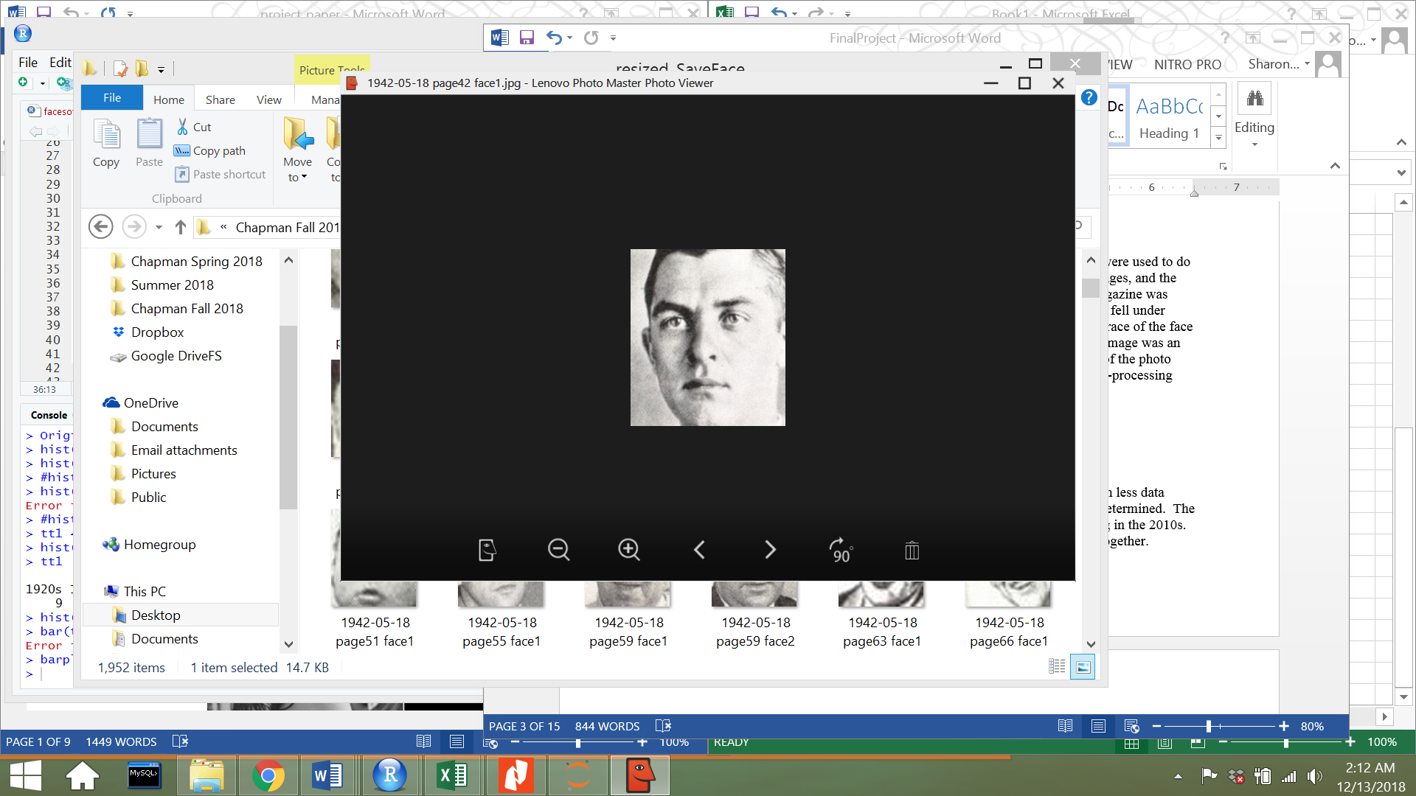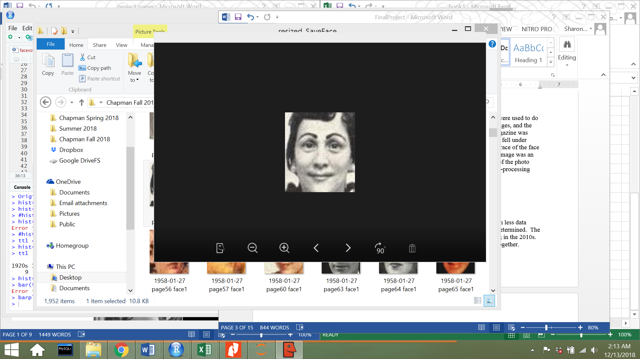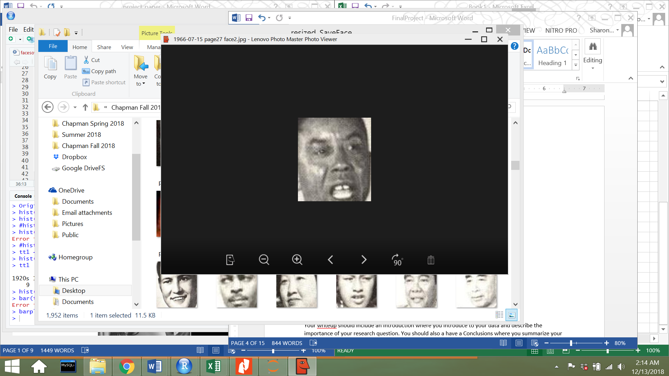

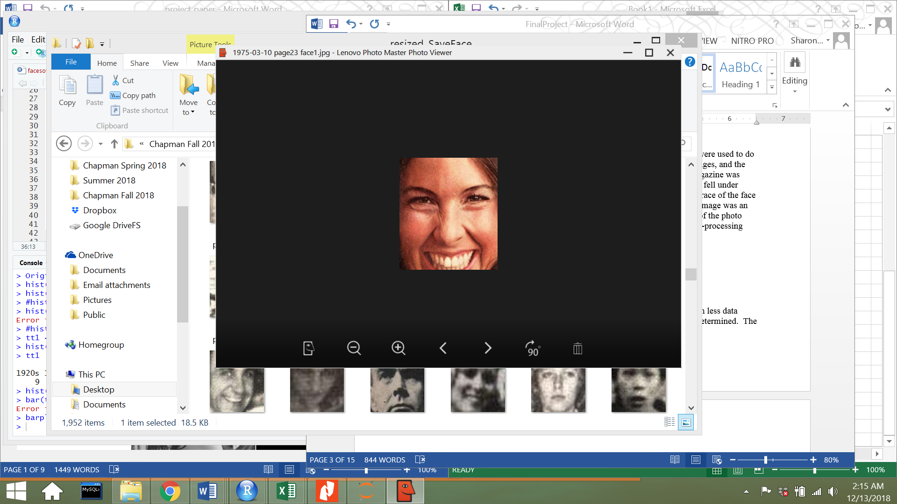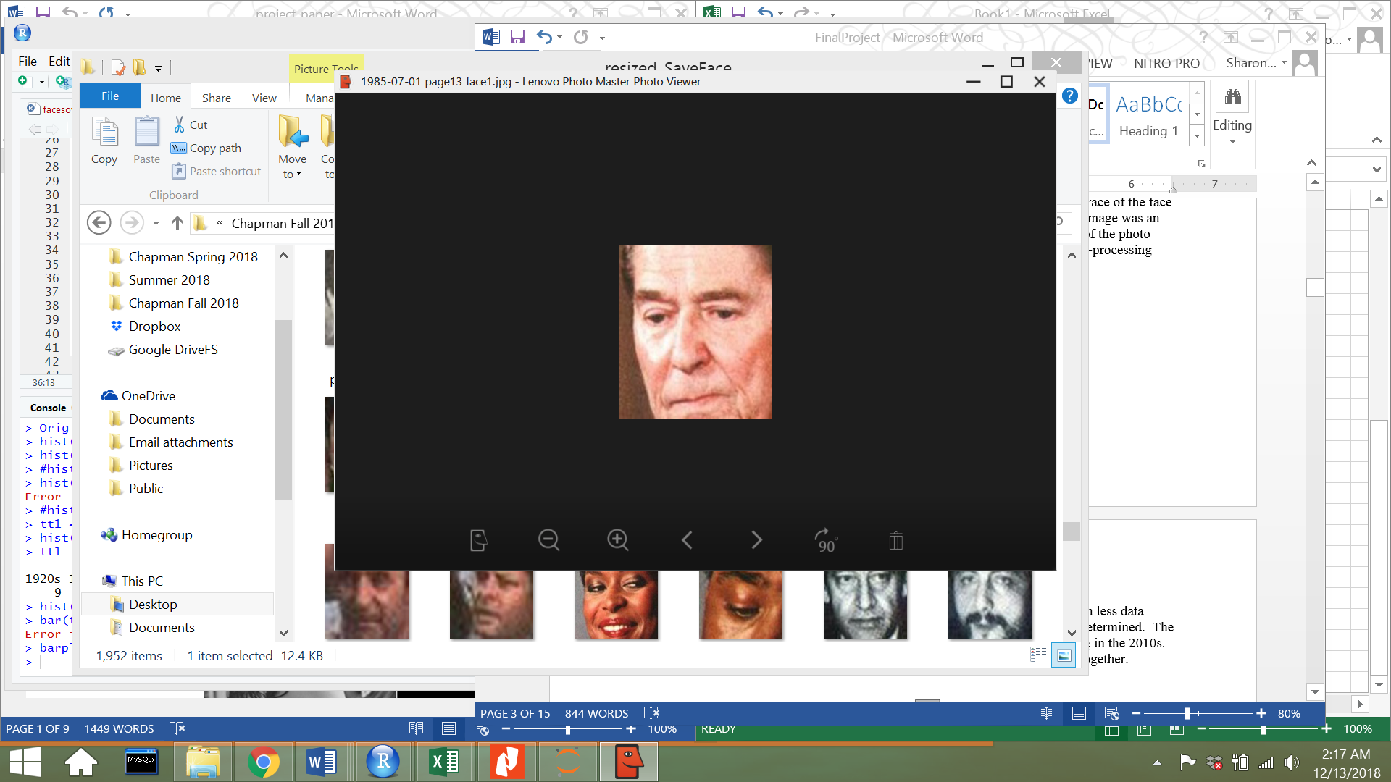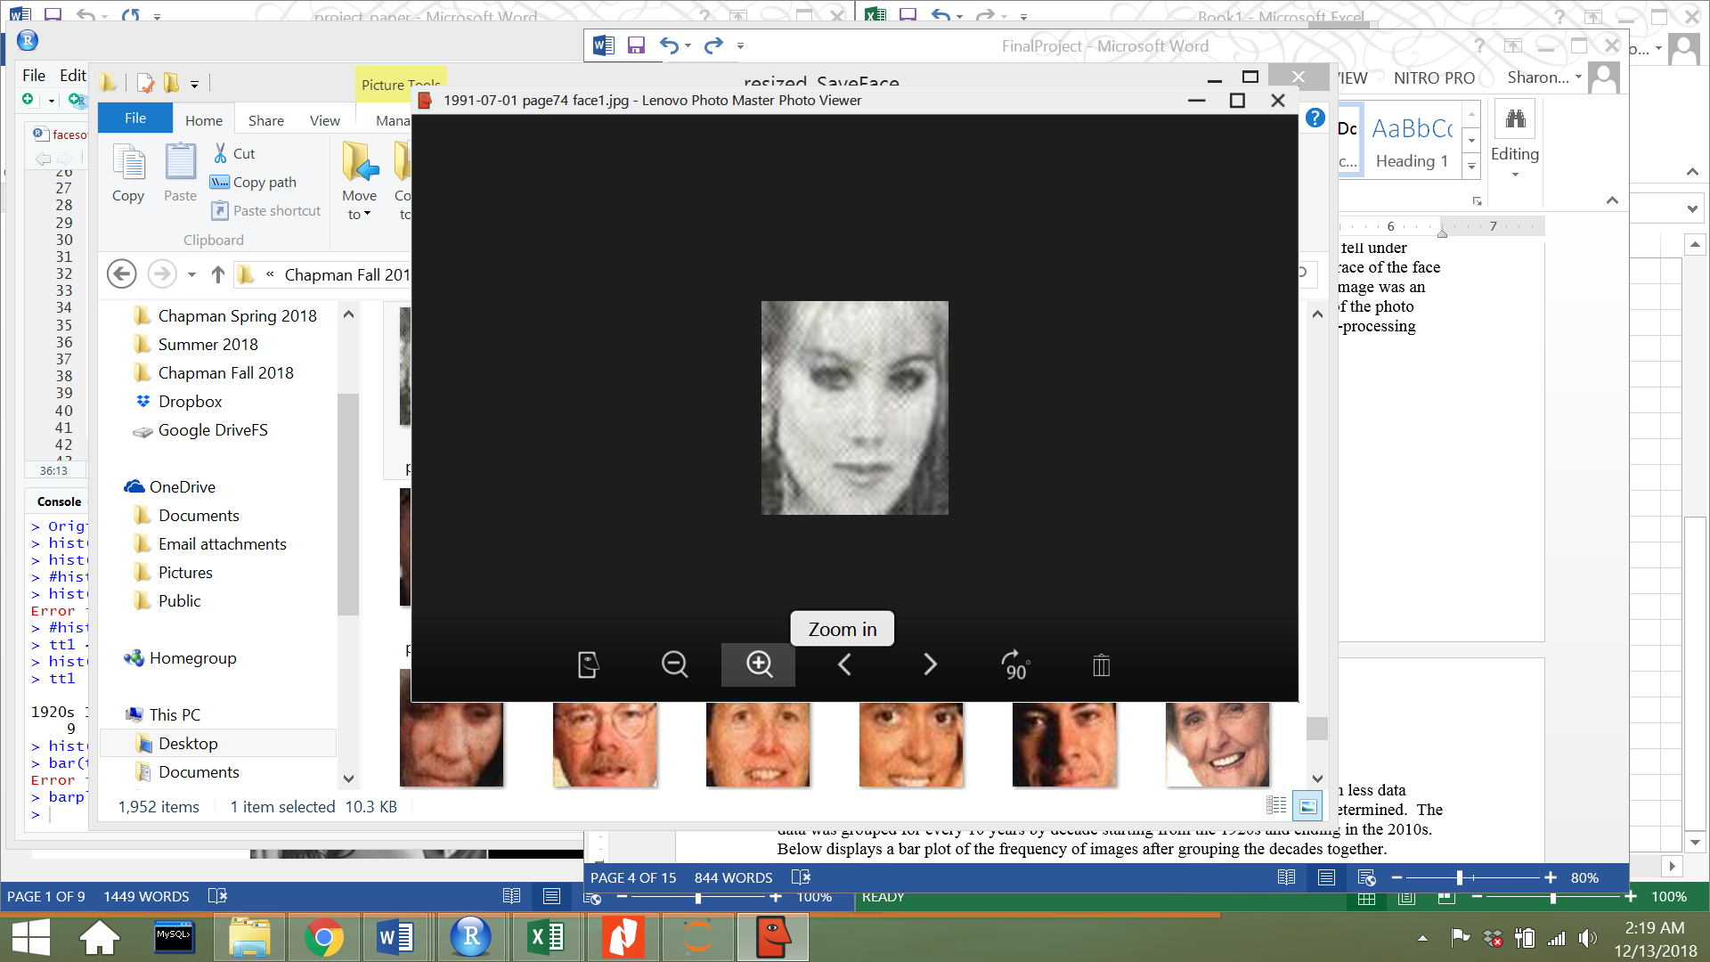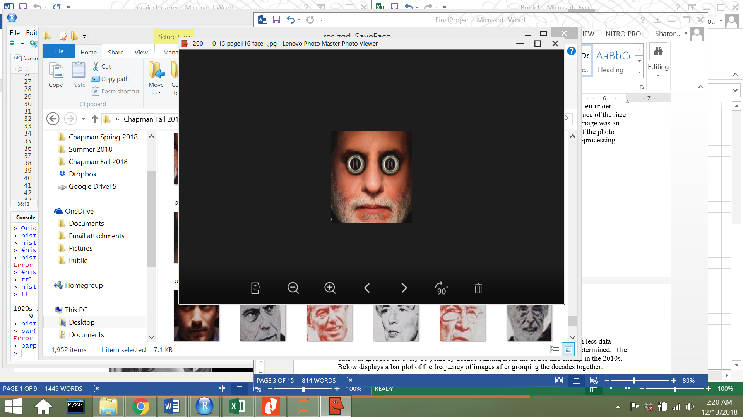

Because there is more data from the 1960’s to the 1970’s and there is much less data from the 1920s to the 1960s, the data was grouped so that trends could be better determined. The data was grouped for every 10 years by decade starting from the 1920s and ending in the 2010s. Below displays a bar plot of the frequency of images after grouping the decades together.

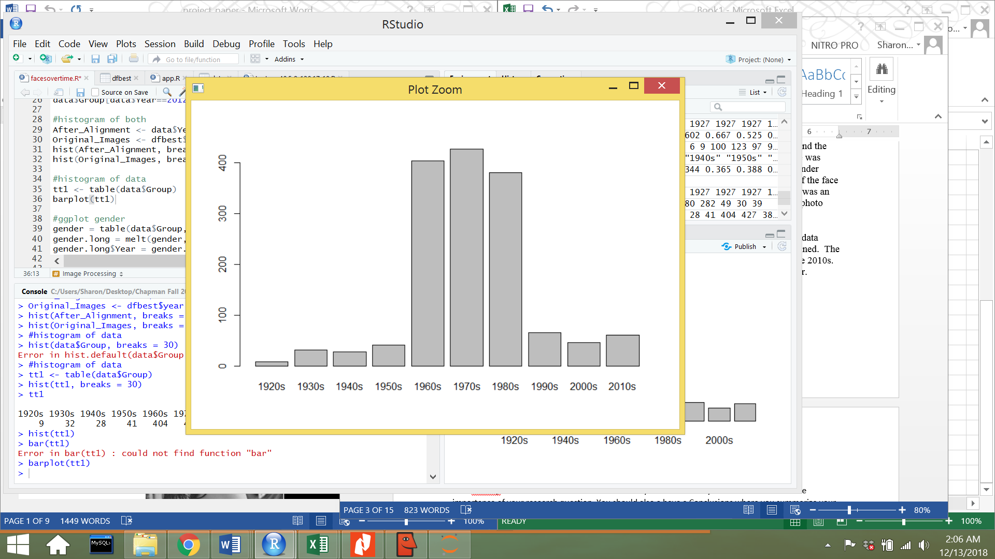

**All Categories**

The first feature that I wanted to analyze was gender representation over the years. Since the frequency of data is so high from the 1960s to the 1980s, a stacked bar plot of percentages were used to visually show males vs. females over time. The pink represents the percentage of female photos and the green represents the percentage of male photos. In the 1920s, only 11% of faces in *Time* were female, and by the 2010 decade, 39% of faces were female, which is still much less than 50%. In the 1920s, 89% of faces in Time were male, and by 2010, 61% of faces were male. The line graph also shows the ascent in representation for females over the decades, with a drastic fall in the 1990s.

 

The next feature that I wanted to analyze was smiling faces over the years. The pink represents the percentage of photos where there was no smile, and the green represents the percentage of photos where a person did smile. In the 1920s, 100% of faces in *Time* did not contain any smiles, and by the 2010 decade, 49% of faces contained smiling photos. The line graph also shows the steady ascent in smiling over the decades.

 

After performing an analysis on gender and smiling faces separately, I wanted to perform an analysis on both gender and smiling faces over the years. To do this, I took a subset of all female photos, and determined what percentage of those female photos were smiling ones. I then took a subset of male photos and found the percentage of smiling photos. The line graph below displays my results for smiling females over time and smiling males over time. Although the percentage of men represented in *Time* is much higher than the percentage of women, the percentage of smiling women is always higher than the percentage of smiling men in every decade. Smiling men show a gradual increase from 0% in the 1920s to 54% in 2010, but smiling women stay in the 50-60% range.



The mean-face algorithm was also performed and used to find the average-face for each decade. The results below tangibly show how faces have changed over time. The first image on the top left shows a composite average face from the 1920s, and the last image on the bottom right shows a composite average face from the 2010 decade. When comparing the gradual changes over the past 100 years, you can visibly see that the faces develop a more defined smile, and the masculine features from the 1920s become softer and more feminine over time. There was not enough image data to perform a racial analysis on representation, but from looking at the average faces, it looks to be majority Caucasian features. It is also interesting to note that we can see that *Time* started with black and white images, and over time introduced more and more color images.



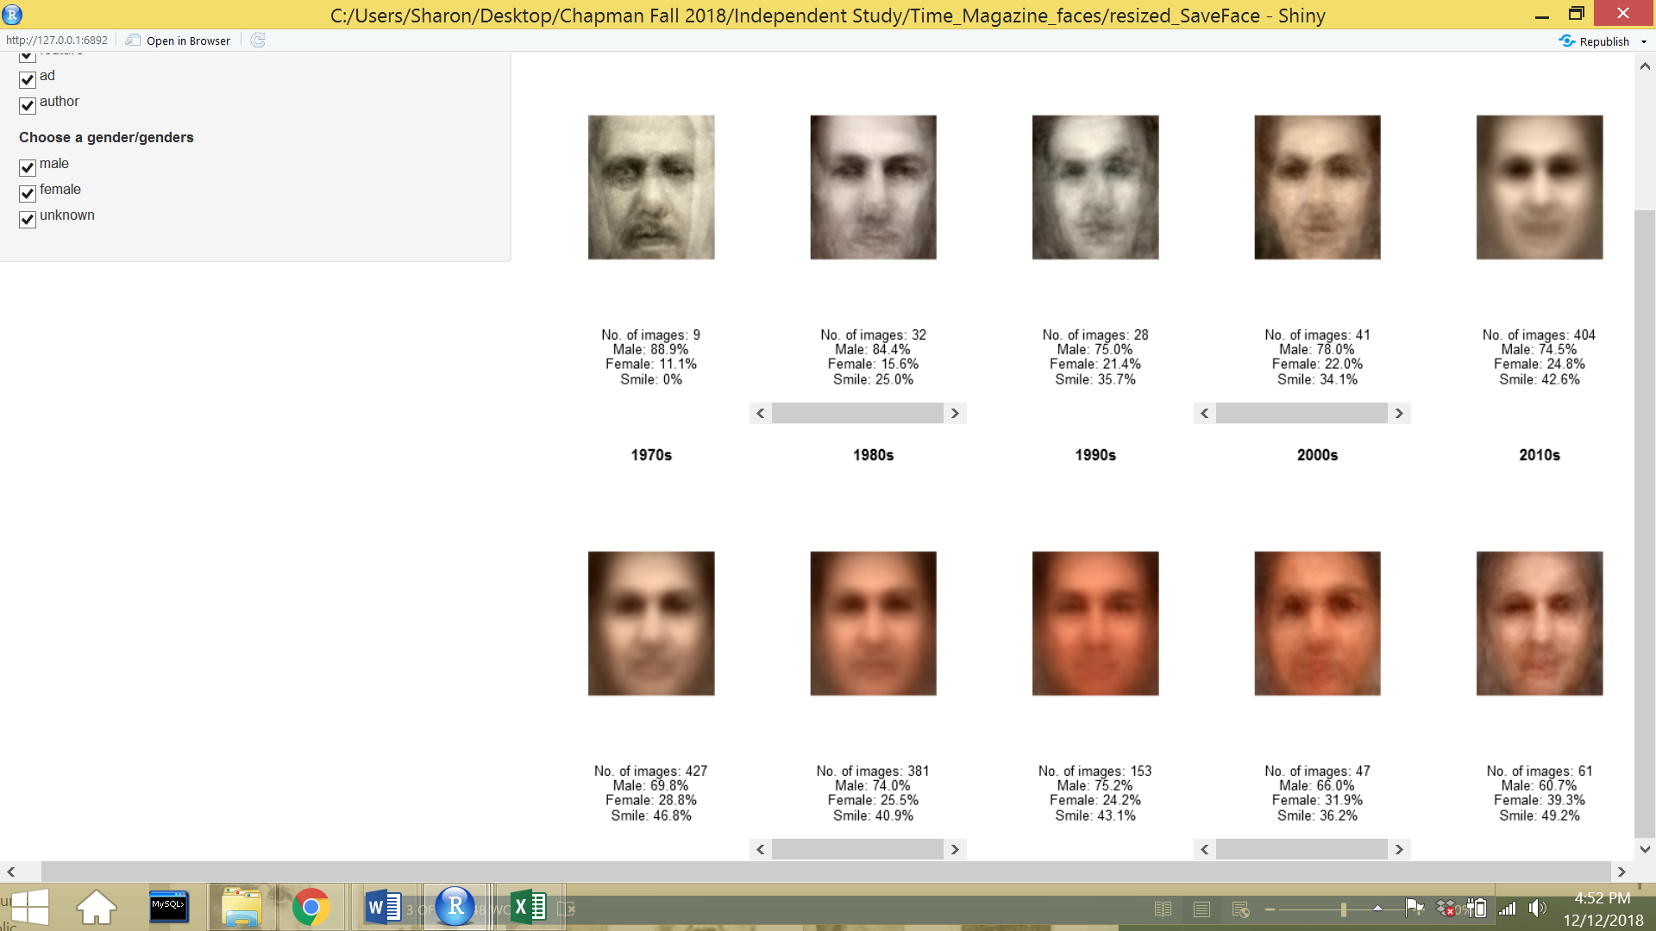

This analysis was done with data from every category (advertisement, author, feature, cover). The same process of data analysis was performed on subsets of category data: feature data first, and then advertisement.

**Category: Feature**

Time magazine’s feature photos comprise most of the image data, 1081 faces, so I expected to get similar results from analyzing data from every category. However, because advertisement data was removed, I wanted to see if it would affect gender representation percentages or smiling face percentages.



As expected, the results for gender representation show a steady increase for women, but never hits at or above 50%. In the 1920s females are in 14% of feature faces, and by 2010 females are in 44% of feature faces. In the original analysis, females were in 39% of images, but when looking at the feature category, it jumps to 44%. The initial hypothesis was the percentage would decrease from the assumption that most women will appear in advertisements, but it is encouraging to see that women are somewhat more equally represented in feature photos.



When looking at smiling in feature photos over time, it is very similar to the initial analysis that was done. The blue represents smiling photos over time where in the 1920s, 0% of faces were smiling, and by 2010, 49% of people were smiling in feature photos.



Interestingly when looking at females smiling and males smiling in feature photos, males again show a gradual incline from 0% to 60%, whereas females tend to remain in the 40-50% range. Another interesting detail to note is that by the 2010 decade, females are smiling less in feature photos, about 35%.

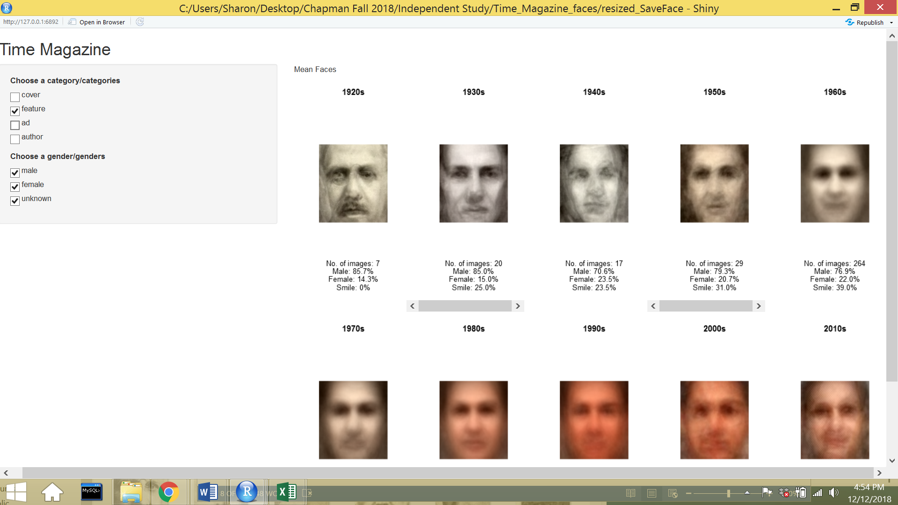

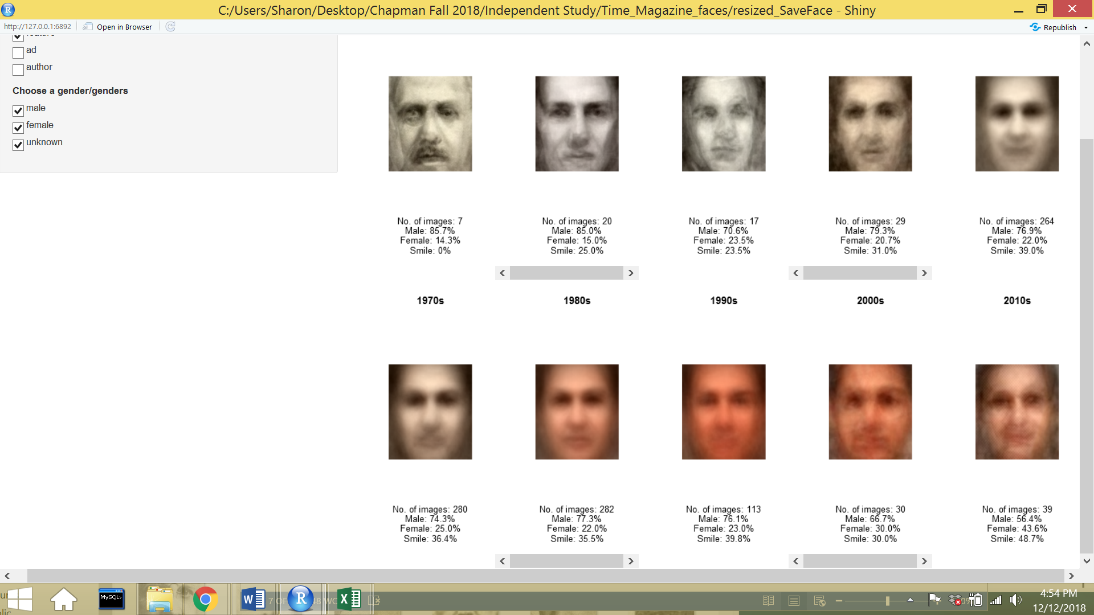

When looking at the average faces of all the feature photos, it does not appear to show much of a difference. One thing that I observed is that the last face that represents the mean-face for 2010 seems like it could be a face of a kind smiling woman. It is encouraging to see change over the years, and would be very exciting to see the mean-face from the 1900s to 2100.

**Category: Advertisement**

The subset of advertisement data are comprised of 362 face images. Gender representation and females smiling in advertisements is a topic of debate in the recent decade. Although this is a smaller subset of photos, it would provide interesting insight to see how portrayal has changed over time.



Although there is a gradual increase in female images in advertisement over time, 2010 shows a male-dominated representation. This may be because there are only 362 images, and most of them lie in the 1960s to 1980s.



Smiling in advertisements show that it went from 0% to being the predominant feature in advertisements. After the 1930s, the percentage of smiling in advertisements never hit below 50%. The advent of digital marketing and digital consumerism must aid in the boom of smiling in advertisements.



The 2010 decade shows such a stark contrast in males smiling in advertisements vs. females smiling in advertisements. Interestingly when comparing men and women smiling in advertisements vs. men and women smiling in feature photos, there are opposite statistics. These findings show the polarization of women in media, where in advertisements they smile, but in feature photos with content on politics, news, and business, they do not smile.

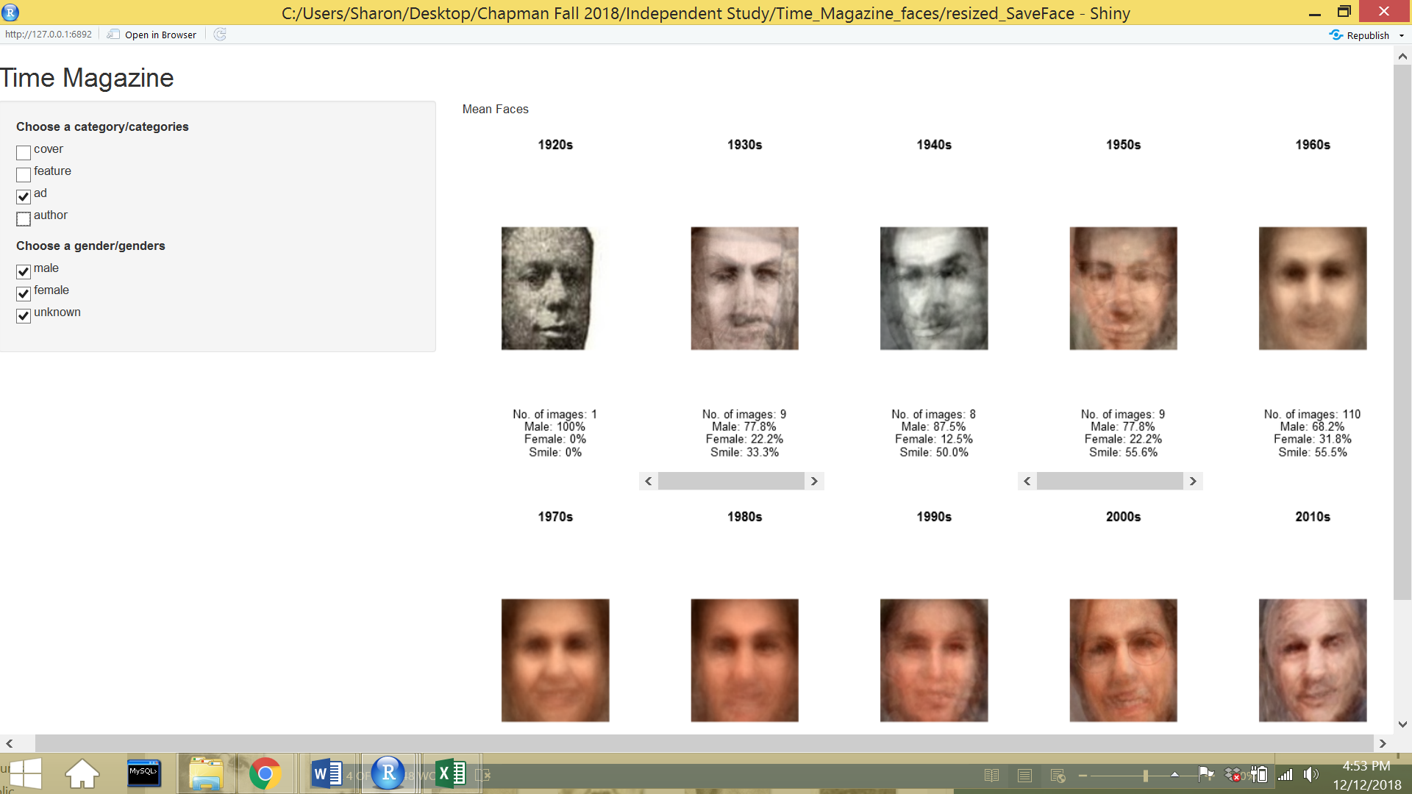

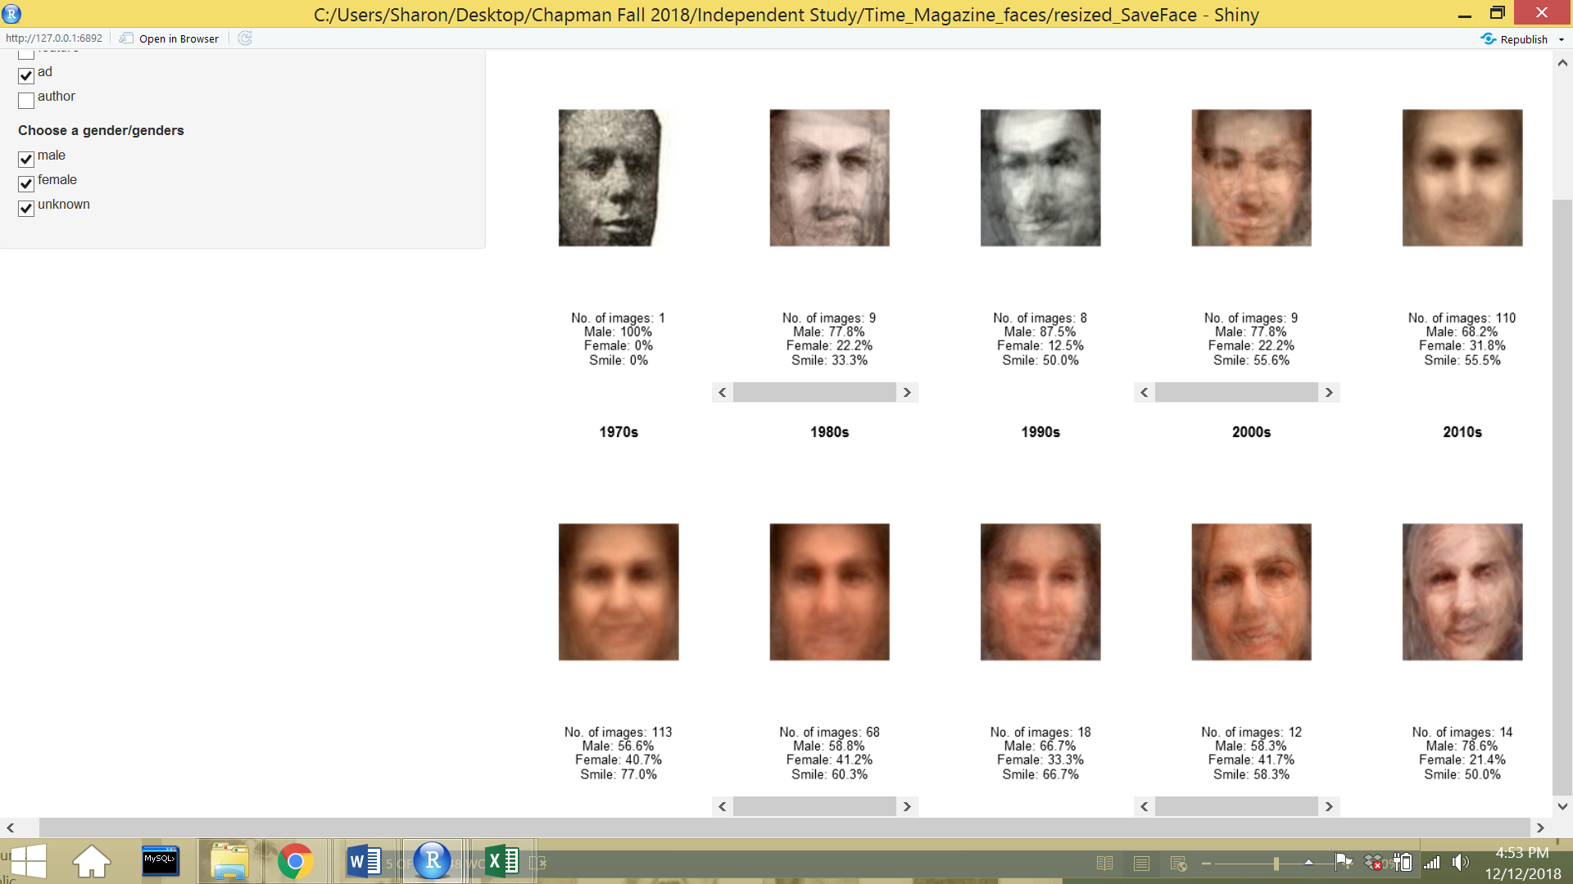

The mean-faces of the composite images show an increase in smiling in advertisement, but mainly represented by Caucasian men.

**Conclusion**

After performing an analysis on smiling as a feature in Time magazine faces over the past 100 years, it is evident that smiling in media is more prevalent today than it was in the past. An article from *The Washington Post* called, “Why people used to look so serious in photos but now have big smiles” describes the changes that occurred. The author Jeff Guo performs an analysis on year book photos over time and explains that in the 1910s, hardly anyone smiled, but after World War II, smiling and grinning in year book photos are a norm. He goes on to explain that with the innovation of cameras, and easy access to self-portraits and photography, happiness has replaced seriousness as the default emotion. Because early cameras had longer exposure times, a neutral expression may have been easier to hold than a smile. But more importantly, the connotation that smiles had were different than they are today. Small mouths were viewed as a beauty standard during the early 1900s, and the only people who grinned in fine arts were peasants, drunkards, and children. The social acceptance of smiling was not accepted until Kodak began a marketing campaign to normalize taking photos, and also portray how much fun it was to take photos. The idea of telling cheerful stories about products in advertising gradually became the norm, and by the 1950s the smile was normalized. It is great to see that the results of my analysis also depict the history of smiling in the United States.

The gender disparity in this analysis was evident in all categories over the past 100 years. It appears that there is a correlation with the rise of the feminist movement in the 1960s to how women have been portrayed in *Time.* It seems to have aided in gender representation for women. Although this analysis shows progress since the 1920s for equal representation for women in media, there is still more progress to be made. An article from *Medium*, called “How Balanced is Gender Representation in Media (2017-2018)” shows statistics for measure imbalances at the top end of media industries. The media industries that the author Michael Taulberg looked into were from books, music, and movies.

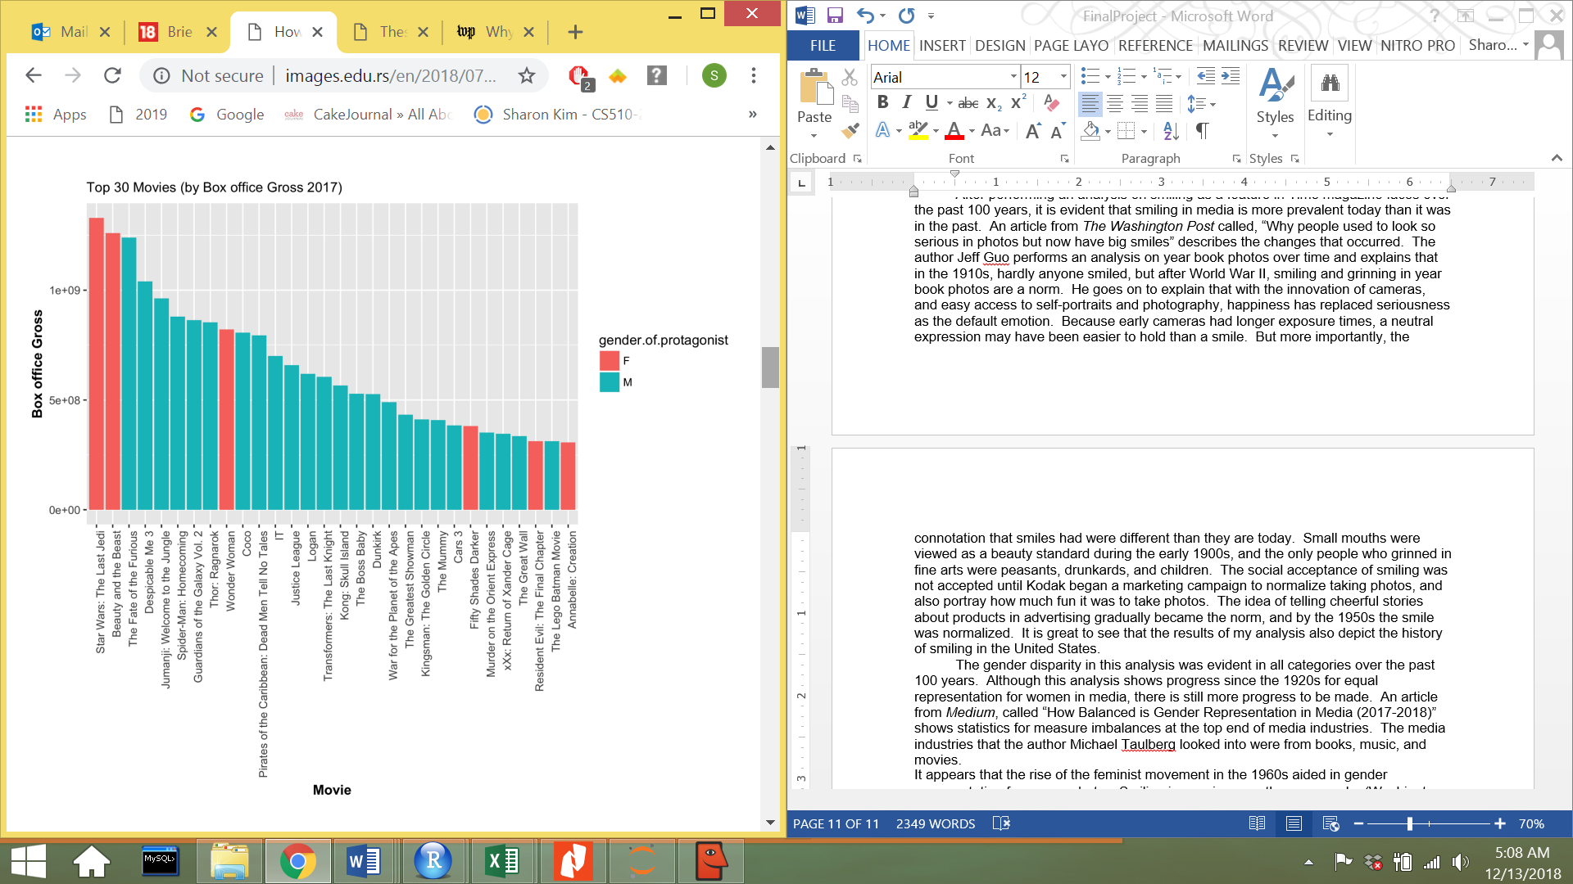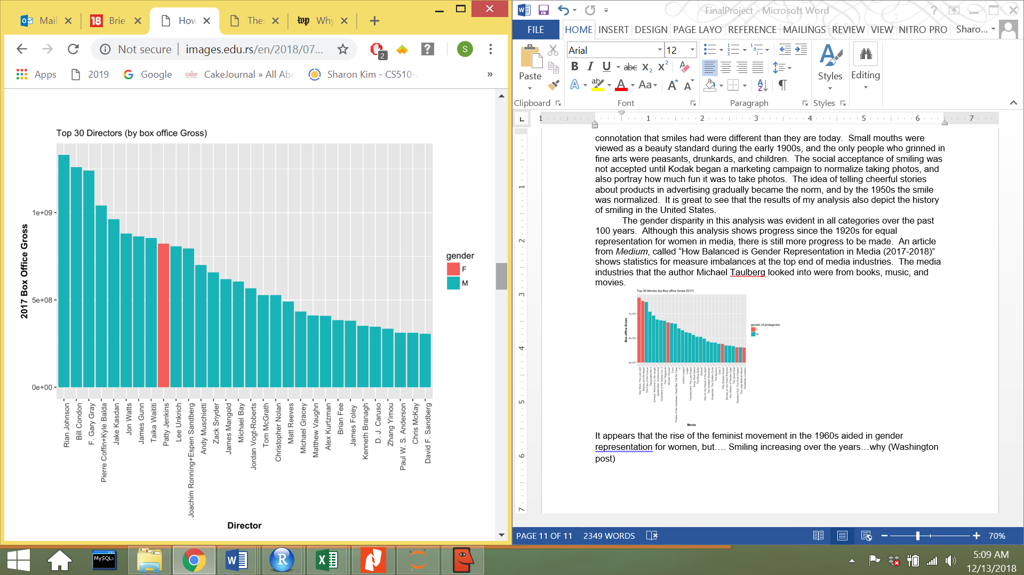

The article continues to show statistics in the film industry where there are more successful male protagonist roles, directors, actors, and even celebrities.

The consistently high percentage of smiling women in every category and decade was extremely eye opening. Before this analysis I was unaware of the longevity that women were being portrayed more as props and accessories than as serious people who have intellectual thoughts and opinions. While society was gradually becoming more accepting of smiling because of the stigma that smiling had in the early 1900s, men also gradually smiled more. But it looks like women were immediately utilized to brand products. Even in 2018, the controversy and complaints over Brie Larson as Captain Marvel not smiling in the movie trailer shows the double standard that women face in media and film.

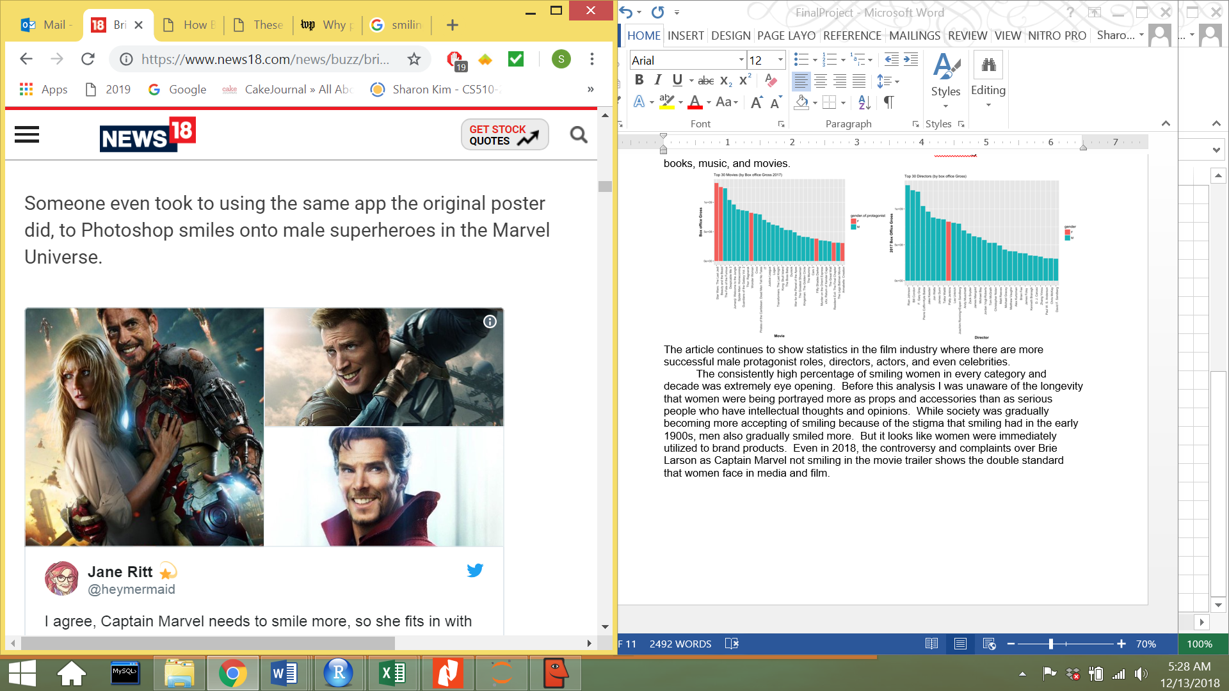

The photo shopped images of other Avengers superheroes smiling accurately illustrates how society and media do not impose smiling standards on men as they do women. This analysis on *Time Magazine* faces over the years reaffirms that this societal “norm” of women smiling is a social construct that can be changed.